Contents

1. Document Introduction 4

2. Client Information 4

2.1 Introduction 4

2.2 History and background of the organisation 4

2.3 Organisation description 6

2.3.1 Organisational structure 6

2.3.2 Area of business 6

2.3.2.1 Head office Location 7

2.3.2.2 Western Cape office 7

2.3.3 Business environment 8

2.4 Description of the general contact particulars 9

2.5 COnclusion 9

3. Project Request 10

3.1 Introduction 10

3.2 Details of the system that the client wants to develop 10

3.3 COnclusion 12

4. Preliminary Investigation 13

4.1 Introduction 13

4.2 Problem Statement 13

4.3 Business goals and objectives 15

4.3.1 Security goal 15

4.3.2 Search goal 16

4.3.3 Efficiency and Automation/reduce email paper trail goal. 17

4.3.4 Reporting goal. 18

4.3.5 Align procurement policy with system goal. 19

4.4 Problems, Opportunities and Directives. 20

4.5 Preliminary assumptions and constraints 26

4.6 Elicitation techniques. 27

4.7 Proof of elicitation. 28

4.7.1 Interviews 28

4.7.1.1 Interview 1: First interview with Ms Vumile Gumbi and the stakeholders. 28

4.7.2 Brainstorming 46

4.7.2.1 Brainstorming 1: Brainstorming session with Altean team and Mrs. Vumile Gumbi. 46

Detailed Explanation from above checklist 47

Detailed Explanation from above checklist 49

Brainstorm write-up: 51

4.8 Conclusion 51

5. Appendix A 52

1. The objective of the Procurement policy 68

2. Role of the Procurement Department 68

3. Vendor setup and onboarding process 68

4. Contract signing Authority 69

5. Procurement authority levels 69

6. Delegation of authority 70

7. Procurement process and accepted norms 71

8. Invoicing process and guidelines 71

9. Competitive bidding 72

10. Ethical Procurement and conflict of Interest 72

11. Supplier diversity 72

12. Compliance 72

13. Related Standards, Policies and Procedures 73

6. Appendix B 81

7. Team Sign off 84

8. Client sign off 85

Document Introduction

Client Information

# 2.1 Introduction

This section describes the history and background of the organization, the organization description, the organizational structure, the organization’s area of business, the organization’s business environment as well as the contact details of our client (Moyo Business advisory).

# 2.2 History and background of the organisation

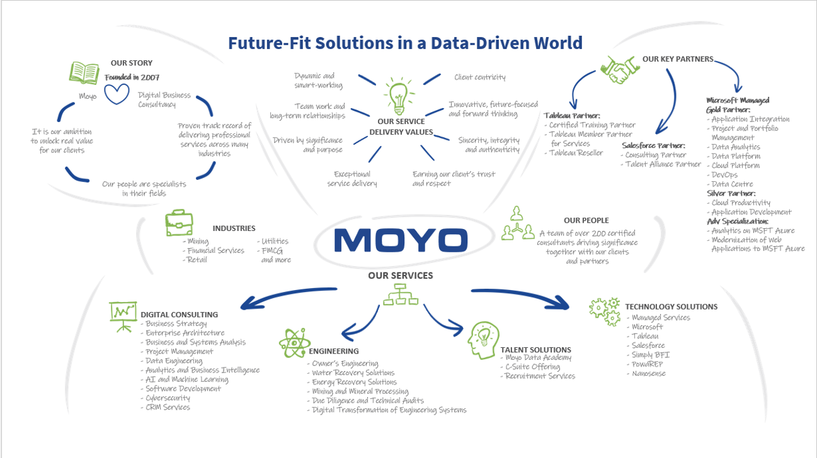Moyo was formed in 2007 by the current managing director Pierre Le Roux. It started off as a business consulting company which remains its core business function as to this day. Under business consulting they provided services such as business analysis, project management and enterprise architecture. It then expanded into services such as MTS, business ventures which includes buying smaller businesses and growing them in order to sell the business or the product that they have built through the venture, engineering and also talent solutions. Moyo operates in various industries such as Mining, financial services, Retail, Utilities, FMCG and many more. These business decisions have resulted in Moyo to be one of the leading Business consulting companies in South-Africa.

Figure : Moyo Summary

Figure : Moyo's Journey

# 2.3 Organisation description

## 2.3.1 Organisational structure

Moyo uses a hierarchical business structure which is based on their relevant business function and department.

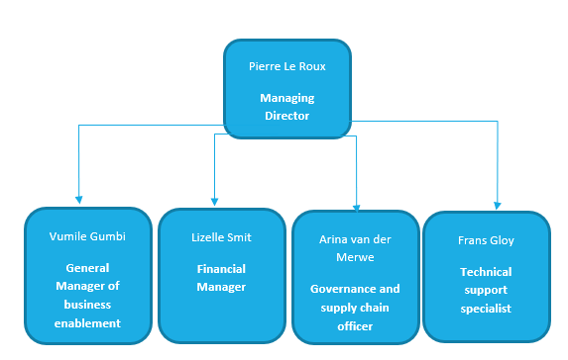

Figure 3: Organizational Structure

## 2.3.2 Area of business

Moyo Business Consultancy has branches in Pretoria, Centurion as well as Cape Town.

### Graphical user interface, text, application Description automatically generated2.3.2.1 Head office Location

Figure 4: Head office location

### Graphical user interface, text Description automatically generatedTimeline Description automatically generated2.3.2.2 Western Cape office

Figure 5: Western Cape Office

## 2.3.3 Business environment

Moyo Business Advisory operates in a highly competitive market which is influenced by technological advancements and digital transformation. Moyo manages these barriers by remaining agile by implementing dynamic- smart working, establishing effective teamwork, long and fruitful relationships, being driven by significance and purpose and delivering exceptional service delivery, focusing on achieving clients trust and respect and having a future based forward-thinking mentality. All their employees are exceptionally skilled in their line of work and passionate about the roles that they play within the organization.

# 2.4 Description of the general contact particulars

**Company**: Moyo Business Advisory (PTY) Ltd.

**Name of Contact person**: Vumile Gumbi

**Email**: [Vumile.gumbi@moyoafrica.com](mailto:Vumile.gumbi@moyoafrica.com)

**Cell- Phone number**: [072 533 8204](tel:072%20533%208204)

**Position:** General manager for Business Enablement

**Background of contact person:** Vumile has been working in business analysis and business consultancy for fourteen years of which nine years are with Moyo, one year at Sanlam, almost two years at UTi Worldwide Inc. and finally two years at Momentum.

**Vumile also possesses the following qualifications:**

* BCom in Information Technology (University of Kwazulu-Natal)
* Postgraduate diploma in business management and administration (UNISA)

# 2.5 COnclusion

This concludes the section which exclaimed the background in the history and background of the organization, the organization description, the organizational structure, the organization’s area of business, the organization’s business environment as well as the contact details of our client.

Project Request

# 3.1 Introduction

The project request section will illustrate the current business problem the client is experiencing with their current system as well as how our proposed system will be able to solve this set of business problems.

# 3.2 Details of the system that the client wants to develop

Moyo has been managing their procurement process through a third party application (SharePoint) and this has been causing them problems and many inefficiencies in the procurement process.

A current issue they are experiencing is with regards to security and integrity of the procurement process. It has been outlined that their current system allows it to be possible to almost bypass supplier vetting completely which results in: The issue of conflict of interest where it is possible for an employee to buy consumable stock from a vendor and get personal kickbacks and the issue of inadequate due diligence on suppliers which ensures that their moral and ethical values and norms between both parties are aligned. It is also possible for values and invoices to be swapped out in the procurement request process which results in the issue of possible misuse of funds which will affect each business units budget allocation. It is also possible to pay a vendor which was not meant to be paid due to this security issue. These issues result in ineffective time allocation due to the fact that it requires extra time to ensure that the information provided was correct, the correct person was paid as well as selecting the correct person who needs to approve the specific procurement request.

Moyo Business Advisory also has the issue of email overload. The stakeholders stated that they need to attach 5 – 6 attachments to each purchase made which creates an extremely long email conversation which they said to be an extremely long and tedious process. Currently SharePoint sends notifications to the user that made a specific request and it can get lost in the massive amount of emails that the stakeholders receive every day. They also have a problem with the users being unable to search for specific procurement items which wastes time since it takes a while to filter through all of the records at any given point in time. This makes it hard for the stakeholders to manage and track how much everyone are spending and what procurement items they are spending it on.

Moyo Business advisory is currently experiencing issues in accurately managing and tracking their own budget as it takes time for a payment to be manually deducted from their budget. It takes MOYO longer to make informed business decisions due to their current system not having any reports. They will need to manually gather their own data and set up manual reports to see their BEE spend report, Vendor Spend Report, Inventory management, Business Unit Spend Report and Budget Variance Report.

MOYO uses an asset management system for assets such as computers and computer parts however they do not have a consumable inventory tracking system (pens, whiteboard wipes, water bottles etc.). This can cause a problem which relates to procurement of these items not being done in adequate time which will render them without the product and successfully managing this situation is more tedious.

We will solve these problems with our procurement system by implementing strict procedures and guidelines to enforce security and integrity of supplier vetting and invoice uploading. This will be done through validation where the system enforces the user to upload two quotes otherwise it will not be able to proceed with the vendor onboarding request. We will implement more validation where only the correct designated people will be able to approve vendors and purchase requests of procurement items. This eliminates the issue of security, integrity, misused funds as well as conflict of interest as it ensures that the vender vetting process is followed.

Our system will solve the issue of email overload by using a user specific “portal page” which is designed in a user friendly manner that will show all of the procurement tasks that need to be done. The system will also provide timely notifications to the users in order to ensure that they stay up to date with all of the information that comes through.

Our system will also provide accurate reporting for the business in order to ensure that they will be able to make accurate business decisions which will relate to the procurement process. The reports can be done on a specified time basis (monthly/ annually) or on an ad hoc basis. The reports will be aesthetically pleasing and professional in design.

Our system will also incorporate a consumable inventory tracking system. This will allow stock to be added onto the system, deducted with stock takes and it will allow the system to send notifications to re-order consumables based on their minimum or maximum re-ordering points.

Our user friendly system will ensure that the process of procurement is effective, efficient and less tedious to complete. This will allow MOYO to spend more time on more important business matters by eliminating intense procurement related tasks.

# 3.3 COnclusion

In conclusion the project request section will highlight the current problems that MOYO is experiencing and how our solution will be able to solve these problems.

Preliminary Investigation

# 4.1 Introduction

The preliminary investigation will investigate the challenges, opportunities, and directives, as well as the business goals and objectives, that our team has gathered from our interviews and brainstorm with our MOYO Client and the stakeholders of the procurement system. In this part, we will discuss our findings as well as the elicitation procedures that we used to obtain this information.

# 4.2 Problem Statement

|  |  |
| --- | --- |
| The problem  of | MOYO is they currently have a procurement system in place that does not really function in the way they want it to function. They are using platforms like SharePoint to document what product or item they want to buy; this is then added to the list of procurement items within a specific budget allocation section. Then there is a request to approve the procurement status of this purchase where the budget owner of that specific section must approve the procurement status before an invoice can be sent. The problem comes in where there is no restriction/security for vendor onboarding like to whom can change the procurement status thus there can be situations where anybody with lack of authority can change the procurement status. There is also a problem with the lack of restricting access to people being able to cross over their allocated budget lines to try and save money on their budget section. There is also a lack of search function for the inventory procurement items list, this makes it hard for budget managers to manage their allocated budgets. They also are currently using an email process to buy procurement items, but this is very tedious and time consuming as the attachments can stack up and easily accrue gaps like paying somebody twice for one item or paying the wrong person for an item. There can also be human error due to having to manually check these email orders and invoices. The current system also bypasses due diligence completely, this creates risk factors for the company because it is hard to see if everybody followed the correct procedures for the procurement process. |
| Affects | Business enablement department, Finance department, Governance & Compliance department, and senior leaders with company credit cards. |
| The impact of which is | MOYO can have financial losses due to payments errors accruing because of the lack of security, due diligence, and functional processes. The processes that are in place are also disrupted on a weekly basis because of corrections needing to be made due to faulty procedures. Thus, these corrections are every time consuming and irritable tasks that need to be manually fixed. When in time crunches these corrections could also be rushed causing incorrect information and approval holding the financial department liable. Process efficiency and budget allocation is also impacted due to these previous stated problem because of the time consumption of these processes to be completed and budgets needing to be change due to unauthorized procurement item approvals and budget lines within budget sections being crossed. |
| A successful solution would | to the current system would be to create a new system free from SharePoint. The system would allow Vender onboarding with security and authorization features; A search procurement items list process ;an approval request and approval authorization process; A purchasing system with each product connected to the supplier that MOYO buys from; Business unit budget allocation; Inventory management and consumable inventory management; Invoicing allocation process e.g. pay with credit card or EFT or Cash; Quality inspection; A reporting process with the following reports: BEE spend report, Vendor Spend Report, Inventory management report (in trend form), Business Unit Spend Report, Budget Variance Report. |

# 4.3 Business goals and objectives

## 4.3.1 Security goal

|  |  |
| --- | --- |
|  | **SMART Goal** |
| Specific | Barriers should be set in place regarding the approval of procurement items in a certain budget line so that only the budget manager of their respective budget line can approve or deny procurement item requests. |
| Measurable | Once the goal is achieved, people will no longer be able to approve or deny procurement item request if they do not have ethe proper authority. People will also no longer be able to sneak in procurement items in other budget lines. |
| Achievable | An authorisation system would be implemented that separates people into their respective budget lines and then also only budget managers will be provided with full functionality that will allow them to approve/deny procurement items whilst other will have that function restricted to them |
| Relevant | This will greatly decrease the risk taken by the company. This will save money for the company. This will save time for the budget managers, the financial team and the governance team. |
| Timely | The implementation of the system and achievement of the goal must be achieved by the end of November 2023. |

## 4.3.2 Search goal

|  |  |
| --- | --- |
|  | **SMART Goal** |
| Specific | The budget managers must be able to search for procurement items within the procurement items list within their specific budget line to be able to keep track of their current budget. They must be able to search by dates, items, budget lines and by owners. |
| Measurable | Once the goal is achieved, budget managers will be able to keep track of their budget line more effectively. |
| Achievable | A search functionality will be implemented that allows for searching by dates, items, budget lines and owners. Then display the list of results on the Procurement list page. |
| Relevant | This improves the quality of life for the budget managers as it saves them a lot of time and human error. This also ensures budget lines are not passed. |
| Timely | The implementation of the system and achievement of the goal must be achieved by the end of November 2023. |

## 4.3.3 Efficiency and Automation/reduce email paper trail goal.

|  |  |
| --- | --- |
|  | **SMART Goal** |
| Specific | Administration work like sending email for procurement item requests should be stopped as the system will now be able to automatically send emails/notifications to budget managers when they need to approve a procurement item as well as an email/notification will be automatically sent to the financial department when they need it comes the purchasing of the procurement item when that item has been approved. |
| Measurable | Once the goal is achieved, there will be less confusion and human errors that occur due to simply missing/forgetting procurement items that were listed. This process of approval to payment would be much more fluent and clutter free. |
| Achievable | An implementation of the Creating of automation email generations that will be sent when email/notifications to budget managers to approve a procurement item when an item is requested. Then once approved and automatic email/notification will be generated to the financial department that will prompt them to make a payment. |
| Relevant | This improves the flow of the procurement process and reduces clutter that was created by sending email on top of email. |
| Timely | The implementation of the system and achievement of the goal must be achieved by the end of November 2023. |

## 4.3.4 Reporting goal.

|  |  |
| --- | --- |
|  | **SMART Goal** |
| Specific | Reports regarding BEE spending, vender spending, inventory management, Business Unit Spending and Budget Variance must be created. |
| Measurable | Once the goal is achieved, managers form the governance compliance, financial and business will be able to make better decisions based on the data that is provided in the reports. |
| Achievable | By creating reports that automatically generate when it is requested or at a certain time of day, or week, or month, or year. |
| Relevant | The current procurement system does not have any reports that can auto generate at the moment. These reports will greatly increase the efficiency of the processes since valuable data can be easily gathered and reviewed. |
| Timely | The implementation of the system and achievement of the goal must be achieved by the end of November 2023. |

## 4.3.5 Align procurement policy with system goal.

|  |  |
| --- | --- |
|  | **SMART Goal** |
| Specific | The new system will take the procurement procedure from the handbook at MOYO into careful consideration and implement the required procedure and processes when it comes to the procurement process. |
| Measurable | Once the goal is achieved, the procurement policy at MOYO will be aligned with the new system. |
| Achievable | By implementing every procedure and policy from the handbook into the new system of operations. |
| Relevant | This ensures that everybody at MOYO who plans on buying a procurement item will follow the current outlined procedures. In doing so, we reduce the risk that the company may face. |
| Timely | The implementation of the system and achievement of the goal must be achieved by the end of November 2023. |

# 4.4 Problems, Opportunities and Directives.

|  |  |
| --- | --- |
| **PROJECT:** Procion System | **PROJECT MANAGER:** Jason van der Merwe |
| **CREATED BY:** Leon Combrinck | **LAST UPDATED BY:** Leon Combrinck |
| **DATE CREATED:** 03/04/2023 | **DATE LAST UPDATED:** 03/08/2023 |

|  |  |  |  |  |  |
| --- | --- | --- | --- | --- | --- |
| **Brief Statement of Problem** | **The impact the problem is causing** | **Expected benefits from any potential solution** | **How**  **quickly can it be resolved** | **What is the underlying source of the problem?** | **What will it cost to solve the problem?** |
| 1. Create a new  web based procurement system that with all the functionality and processes followed from the procurement procured a policy from the MOYO handbook. | This impacts the entire flow of the procurement process since the current process is error prone and time consuming. This is used to the current system lacking the clear required process needed for procurement. | This will free up precious time for all parties involved.  This will also solve most problems and errors that are currently occurring in the system.  Shifting the current system to an independent web-based system catered towards MOYO’s needs will ensure effectiveness and efficiency of the procurement process. | 4 months | MOYO has a system now, but it does not operate in the way they want it to operate. The current system has short coming s regarding the security, due diligence aspects, reports and to align the procurement policy of the company with the new system.  Due the lack of security, automation and due diligence in the current system that is implemented. | There is no budget set aside for this project. The work will be done with hard work and dedication. |

|  |  |  |  |  |  |
| --- | --- | --- | --- | --- | --- |
| 2. Create an authority hierarchy with different budget lines/sections and one budget manager oversees their respective budget lines. This creates access restrictions on certain functions that people who are not budget managers do not have. This creates security for those who would for example be able to approve a procurement request. | Due to those problem users who are not authorised to approve a procurement request are able to do it. Also, users who are part of one budget line can sneak procurement met items into another budget line for them to save money on their budget line. | This will be one by giving the admins of the system full access to the system and will be protected by a username and password whiles procurement users will have restricted access to make sure only budget manager can approve procurement requests.  The budget lines will also be split up so users and the budget manager of that line will be place within the section of that budget line that they are assigned to ensure that users cannot cross budget lines. | 4 months | MOYO has a system now, but it does not operate in the way they want it to operate. The current system has short coming s regarding the security, due diligence aspects, reports and to align the procurement policy of the company with the new system.  The underlying problem comes in where users are now approving their own requests then costing the company money by sending procurement items that would otherwise not be approve in the first place to be bought.  Another problem would be users sneaking budget line items into other budget line in order for them to save on their budget line causing that budget their budget line being able to spend more money the other budget line potentially going over their budget. | There is no budget set aside for this project. The work will be done with hard work and dedication. |
| 3. Create a search function that will be used by the people who will make use of the system to search for a listed item or items within the current procurement item list. This search function should allow for search by dates, items, budget lines and owners. | Due to these issues budget managers and heads of departments need to manually collect the data that they need. This is error prone due to thing that could easily be missed and is also takes a lot of time | The current system needed the implementation search function that will be able to search by owner, budget line, dates, and budget line items.    This will help the budget managers to keep track of their respective budgets and also make editing procurement requests much easier. | 4 months | MOYO has a system now, but it does not operate in the way they want it to operate. The current system has short coming s regarding the security, due diligence aspects, reports and to align the procurement policy of the company with the new system.  The underlying problem is that with no search function it is hard for budget managers to keep track of their budget. This causes them to go over their budget allocation and causes the company to lose money. | There is no budget set aside for this project. The work will be done with hard work and dedication. |
| 4. The manual completion of reports by  That is required regarding the procurement system. | People like heads of departments and budget managers can lose track of the data since it's very unorganised and can thus be prone to errors.    This can lead to budget managers making inaccurate decisions. | A complete report will help budget manager to and heads of departments to clearly see the data from the system in a clearly formatted way. This allows for better decision making regarding that data. | 4 months | MOYO has a system now, but it does not operate in the way they want it to operate. The current system has short coming s regarding the security, due diligence aspects, reports and to align the procurement policy of the company with the new system.  The Current system has no reports at all thus, the new system needs a report system that generates all the required reports. | There is no budget set aside for this project. The work will be done with hard work and dedication. |

|  |  |  |  |  |  |  |
| --- | --- | --- | --- | --- | --- | --- |
|  | **Brief Statements of Opportunity** | **Urgency** | **Visibility** | **Annual Benefits** | **Priority or Rank** | **Proposed Solution** |
| 1. | Reduce current email system paper trail with an automated system for the vender onboarding system. | High | High | Unknown | 3 | Create a new system that operates an implements vendor onboarding system with a dropdown list and automated email reports. |
| 2. | Implementing a search function for procurement items list. | High | High | Unknown | 2 | Create a search function and page within the new system that allow to search by keywords or dates within specific budget lines. |
| 3. | Transforming the current SharePoint system into a completely new and independent procurement system. | High | High | Unknown | 1 | Replacing the current SharePoint system with an efficient independent system that can do all the functions that is needed for the procurement system in the form a web-based system. |
| 4. | Having a task portal interface of important tasks that need to be completed. | Medium | High | Unknown | 5 | Creating a portal to see the specific task for each person and being able to mark them off as you complete then. |
| 5. | Having inventory stock take for a purchase scheduling process. | Medium | High | Unknown | 4 | Create a notification that notifies budget owner when it is time to reorder before stock gets to 0. (Dealing with a lack of stock before it happens rather than when it happens) |
| 6. | Having a vender audit alert system. | Medium | High | Unknown | 6 | Create an annual alert that checks verification for the vendor onboarding process. |

|  |  |  |  |  |  |  |
| --- | --- | --- | --- | --- | --- | --- |
| **Brief Statements of Directive** | | **Urgency** | **Visibility** | **Annual Benefits** | **Priority or Rank** | **Proposed Solution** |
| 1. | MOYO requires that we adhere to the POPI act to ensure privacy and security of customers information is not taken lightly. | High | High | Unknown | 2 | We will diligently follow the terms as stated in the POPI right. |
| 1. | MOYO requires that the system must allow only specific user (Budget managers) to perform certain task (approve procurement items in their associated budget line) | High | High | Unknown | 1 | The system will assign each budget manager to their specific budget line to create authority on what task they can performed by what budget manager and the respective budget line they are representing. |

# 4.5 Preliminary assumptions and constraints

|  |  |
| --- | --- |
| Assumptions | Constraints |
| * Budget managers keeps within their allocated budget. | * All the requirements of the procurement system are met within the limited time period. |
| * Only the budget manager can approve a procurement item within their specific budget line. | * The coding barrier of the procurement system needs to meet the requirements since we still need to learn angular and Microsoft stack. |
| * Can only make use of the new procurement system to be able to buy procurement items. | * There is no budget for creating the procurement system, but rather. |
| * Have of stable internet when making use of the procurement system. | * Not all the users of the system will be able to make use and understand the new procurement system in its entirety. |
| * Procurement items will only be invoice once they have been approved by their respective budget manager. | * Getting everybody to move from the emailing process to the new procurement system. |
| * The user of the system knows that the system operates and how to properly use the system. | * Getting People accept and comply with the new changes of the system and making use of the new system and its processes. |
| * The supplier of the procurement item has stock of the item being purchased. |  |

# 4.6 Elicitation techniques.

|  |  |
| --- | --- |
| **Elicitation Technique** | **Motivation for Elicitation technique** |
| Interview | * The interview process is our first and main form as elicitation technique used to gather information from our client MOYO regarding the procurement system. The Interviews would also be held virtually as it is most convenient for the client and the stakeholders. * The interview is used since it’s one of the most effective and efficient ways of gathering mass amount of information in a short amount of time. This is especially important since our client is extremely busy, and we do not want to waste any time. * By making use of the interview elicitation technique each member of our team can ask insightful questions regarding the function of the procurement system we are expected to create. This gives us a greater understanding of the system but also the business and how it functions. * The interview also helps us as a team to get to know our client and the stakeholders which would not be possible with something like questionnaires or prototyping. |
| Brainstorming | * The brainstorming process was used as the second elicitation technique as this allows the team to gather our thoughts on the procurement system and how we will implement and create the system. * Brainstorming also helps us a s a team come up with creative solutions to the complex problems we face with the procurement system. * Brainstorming is the best way to effectively and efficiently gather new ideas from everybody and then find the most feasible and suitable one for our situation. Thus, it helps us find possible problems and constraints as well as creative ways on how these problems and constrains can be solved or worked around. * Brainstorming also creates an opportunity for all team members to contribute their ideas freely. * Most Importantly the brainstorming session allows us to talk about and evaluate the information that we received form the interview with our client MOYO. |

# 4.7 Proof of elicitation.

## 4.7.1 Interviews

### 4.7.1.1 Interview 1: First interview with Ms Vumile Gumbi and the stakeholders.

|  |  |  |  |  |
| --- | --- | --- | --- | --- |
|  | | |  | |
|  | **Preparation checklist** | |  |  |
|  | No | Task | Done |  |
|  | | |  | |
| 1 Decide which type of interview | | | ✓ |  |
|  | | |  | |
| 2 Decide on interview goal | | | ✓ |  |
|  | | |  | |
| 3 Create list of questions | | | ✓ |  |
|  | | |  | |
| 4 Identify potential interviewees | | | ✓ |  |
|  | | |  | |
| 5 Decide on location for interview | | | ✓ |  |
|  | | |  | |
| 6 Invite interviewees | | | ✓ |  |
|  | | |  | |
| 7 Send questions to interviewees (optional) | | | × |  |
|  | | |  | |
| . | | |  | |

#### Detailed explanation of the preparation checklist

1. Decide which type of interview.

• This will be a semi-formal interview that we will be conducted online on the Teams platform. The people who we will be meeting with is Mrs. Vumile Gumbi and the stakeholders of the procurement system. We have set up questions that we will ask during the interview.

1. Decide on the interview goal.

• The Team would like to have the interview with the client and the stakeholders where we can ask all the questions regarding the procurement system that we are currently designing for MOYO. This is to get a understanding of how this specific system should function and what exactly they want to achieve from this system. This gives the team a good stance on how we are going to approach this problem and ultimately how we are going to solve it.

1. Create list of questions.

**General Questions:**

* 1. What is the Backgroundof each stakeholder?
  2. Current documentationused in the business (is it part of the procurement document already sent, BEE template or reports)
  3. Is there an existing procurement system, if so, how does the views of each page look like?
  4. What capabilities does the current system have in place and what are some shortcomings?
  5. Who does this affectthe most like for example specific individuals or departments?
  6. What are the Impactsof these problems and affects (How does the issue of your system impact the department, organization, financial and time wise)?
  7. How would you benefitfrom this system?
  8. What opportunitiesand directivesdoes this new/future system create?

*8.1* Should some systems/functions be combined?

*8.2* Are their paper-based processes that should be automated?

*8.3* We are aware about certain things needing to be kept private. What else should we know about?

*8.4* Are their specific users that should be performing specific tasks?

* 1. What business assumptionsand constraintsshould we be aware of?
  2. Each user on the system needs their own login, should there be access levels to restrict the view of certain data.
  3. How would you like to implement the system? (Mention of azure, website? mobile?)
  4. As seen, it looks like emails/ written documents are sent to different stakeholders (finance, procurement, requisition etc.) Which would be the best implementation of this system wise (Prepopulated document sent, automatic notification on “portal” and once approval is made a document is ready for download?)
  5. In the procurement process, what is the most iterative task that needs to be complete.
  6. Regarding the automation of the system, how should that be implemented and how should it function? Like the automatic reordering for example Making use of the calendar to calculate when usually certain supplies should be ordered
  7. How is the process of faulty supplies handling a quality inspection?
  8. Would it be beneficial to you if the rest of the company (e.g.: procurement, requisition and finances) have access to the system in order to streamline the procurement process?
  9. What are the goalsfor any of the systems?

1. Identify potential interviewees.
   * We will be conducting this interview with -
   * Mrs. Vumile Gumbi - General business Manager MOYO.
   * Mrs. Arina van der Merwe - Governance and supply chain officer.
   * Mrs. Lizelle Smit - Financial Manager.
   * Mr. Frans Gloy – Technical support specialist.
2. Decide on location for interview.

* Mrs. Vumile Gumbi decided that the meeting will be held on Teams.

1. Invite interviewees.

* Mrs. Vumile Gumbi, Mrs. Arina van der Merwe, Mrs. Lizelle Smit, Mr. Frans Gloy was invited to the interview using Teams.

1. Send questions to interviewees (optional)

* We did not send our questions to Mrs. Vumile Gumbi beforehand.

|  |  |  |  |  |
| --- | --- | --- | --- | --- |
|  | | |  | |
|  | **During Elicitation checklist** | |  |  |
|  | No | Task | Done |  |
|  | | |  | |
| 1 Describe purpose of interview | | | ✓ |  |
|  | | |  | |
| 2 Confirm interviewees' roles | | | ✓ |  |
|  | | |  | |
| 3 Address any concerns | | | ✓ |  |
|  | | |  | |
| 4 Explain how information will be recorded and shared | | | ✓ |  |
|  | | |  | |
| 5 Ask predefined questions | | | ✓ |  |
|  | | |  | |
| 6 Summarize the session | | | ✓ |  |
|  | | |  | |

#### 

#### Detailed explanation of the during elicitation checklist

1. Describe the purpose of the interview.
   * This meeting will discuss the requirements gathering for our procurement system that will be developed. We will talk about reports, requirements, specifications, business rules and other business information which relates to procurement process.
2. Confirm interviewees’ roles.
   * Mrs. Vumile Gumbi will serve as our organizational contact and General manager. Mrs. Arina van der Merwe will serve as Procurement governance and requirements provider that overseas procurement processes. Mrs. Lizelle Smit will serve as financial manager as well as financial requirements provider. Mr. Frans Gloy will serve as the technical support specialist, however he could not attend the meeting.
3. Address any concerns.
   * All the concerns that the team and client had regarding the procurement system and processes was addressed in the meeting. More information is provided in the interview writeup.
4. Explain how information will be recorded and shared.
   * The information gather during the meeting was done so by making use of recording since the meeting was virtual. The client was aware of this and agreed to this arrangement.
5. Ask predefined questions.

**General Questions:**

* 1. What is the Backgroundof each stakeholder?

**A:**

Vumile: “We started off in 2007 as a consultant company in where we had business analysis, project management, enterprise architecture etc.… Under digital consulting is the core of the business and that is ultimately where we started and since then we expanded the core of the business and that is where you will see now, we have MTS (Recruitment and training) where we Have technology services, ventures where we have smaller business that we build and sell the tech and product that we built there. Thus, the core of the business is still in consultation and providing IT consulting professional services, it’s just that we expanded as we have grown in the market to include other services as well.”

* 1. Current documentationused in the business (is it part of the procurement document already sent, BEE template or reports)

**A:**

Lizelle: “No not that I know of at the moment”

Vumile:” There is no existing stuff, but these are the things that we would like implemented within the system. The reason for this is because there is no data being saved any ware so we cannot compile those reports. SharePoint does not store anything about the vender or has any BEE connections, only the list. So, we don’t have anything, but we would like to have that.”

Arina:” I can probably only give you a excel spreadsheet on the BEE spend report to show how that is made up.”

* 1. Is there an existing procurement system, if so, how does the views of each page look like?

**A:**

Vumile: “We don’t have a proper system or the system that we really want, but we do have now is that we make use of Microsoft free tool SharePoint that creates lists and that is where you can go and capture what you want to buy and select the budget line for that item then you can submit it then it goes to the line manager to be approved and then it sends an email to finance.”

Arina:” Regarding the view, I’ll make a note in sending that to you guys form the procurement procedure handbook.”

* 1. What capabilities does the current system have in place and what are some shortcomings?

**A:**

Lizelle: “So the short comings are that with the email process some people use it some people does not use it at all, so we have a mixture between emails and the schedule.

Vumile: “Ok I can demo you what we have right now. So basically, we use SharePoint and let’s assume I want to buy something: on the top right conner I will click on new for new procurement request, then it will open up a side view where we are going to enter our information. So first is item description were I can for example say I want to buy a laptop, then owner where I will add my name. Then there is an auto notify finance checkbox which I click yes. Then the next is requisition status I enter approval required, and afterword the budget owner would come in here to approve or deny. Then we have source where we would enter invoice/quote followed up by quotation where you put the amount quoted for the product you want to buy in this example the laptop. Then next is asset number and serial number but I ignore both. Then we have provider which is a set list of people we buy from, so for the example I will select axis for laptop. Next is deposit due date that you can fill in if you have one along with deposit amount and amount outstanding. Then we have full payment date Which you most likely going to fill in along with total amount. Then we have pay on field that would mostly be if you buy something with credit card for example then you upload the invoice of that purchase. Then budget allocation where you choose what budget the purchase is coming from. Then you have payment method like cash or credit etc. Next is invoices that you can upload and attach when you like. Then payment status, this is where you need to select what is going to happen like deposit only, allocation made, total payment required, paid total, partially paid etc. Then we have cc providers and sign-up status field. Then we have Providers email where you provide the email of the provider you are using that send email directly to them. Then lastly attachments that could be any attachment you want to add like a quote or invoice. Then you click create that will create a new procurement item within the procurement list. Then a person then can go to the item they added and comment @Vumile for example and that will send an email to me to ask to approve the item. Then I will change the status to approved and mention the person who requested and the finance team so that they can then move on the buy that product. The challenge however come in that it’s easy to create a new procurement item, but I can’t easily find one because there is no search functionality. So it’s hard to see and track how people are spending and what they are spending on. This means nobody can manage their budget. There is also not many securities and controls on this process because anybody can go into any item and approve that item even if they don’t have the authority. That the current process or people also just use email.”

Arina:” Yes so another shortcoming is that this current system is bypassing due diligence completely so if a person has three supplies if need to do due diligence on those suppliers to minimize risk on our side. So, there is no way for me to know which clients we have done due diligence on or not, because that process is completely missed.”

* 1. Who does this affectthe most like for example specific individuals or departments?

**A:**

Lizelle:” That would be us and Mr. Frans Gloy. So, Mrs. Vumile Gumbi business enablement department, Mrs. Arina van der Merwe governance and compliance department, Mrs. Lizelle Smit finance department and Mr. Frans Gloy technical support.”

Vumile:” Yes me especially since I am the biggest spender but also any senior members with company credit cards that needs to buy anything using the company credit card, since now they will have to follow the procurement procedures when they do buy something.”

* 1. What are the Impactsof these problems and affects (How does the issue of your system impact the department, organization, financial and time wise)?

**A:**

Lizelle:” So there are a couple things that happen firstly we have financial losses because we are paying somebody we are not supposed to be paying. Secondly it disrupts our processing each week, because every week we do payments(Wednesdays and Thursdays), so that takes a while to get the right information and get the right person to approve that information, because we can see its wrong so we send it back and we need the payment now so we are pressed for time so we just do it and then it’s wrong then my head is on the block because I am the head of finance.”

Vumile:” So on my side is the company is big on driving process efficiency and governance, so when the company started there was only four guys with on office, but now as the company is getting bigger with more people it is very important for us to focus on the appropriate controls and governance that is required within internal processing. We never really focus on the company internally because we are so pressured time wise. The impact of capitalizing on BEE spending as well.”

Arina:” This is also a very high-risk procedure and there are so many places that we are at risk”

* 1. How would you benefitfrom this system?

**A:**

Vumile:” Cost reduction and fraud reduction.”

Arina:” risk reduction.”

* 1. What opportunitiesand directivesdoes this new/future system create?

*8.1* Should some systems/functions be combined?

*8.2* Are their paper-based processes that should be automated?

*8.3* We are aware about certain things needing to be kept private. What else should we know about?

*8.4* Are their specific users that should be performing specific tasks?

**A:**

Lizelle: “We will need that last point. So, lots of people can make a request but only one person has the authority to approve that Procurement item. But also budget managers can only approve what is in their budget line for example Vumile cannot approve my budget lines, since she does not have authority over mine only I can a same way around.”

Arina:” Regarding opportunities of the current email paper trail to be changed and completely implemented within the new system. Integration wise probably implement the reports back into xero.”

Lizelle:” Currently what we are doing is on every single expense we attach an email this creates a tedious and long invoice with 5-6 attachments of emails going back and forth so and automation on that process would help.”

* 1. What business assumptionsand constraintsshould we be aware of?

**A:**

Vumile:” the only constraint that I can think of is getting people to align with the procurement process. Because some people are using email, and some are using the SharePoint so for us the constraint would be getting people of the email and start making use of the system that follows the procurement processes and procedures. Another constraint would be that you can’t just go and buy from anybody there must be a process where we get the three quotes from the different providers that then goes to Arina that checks the governance and compliance before you buy an item.”

* 1. Each user on the system needs their own login, should there be access levels to restrict the view of certain data.

**A:**

Lizelle:” I would like for the finance department to still see all the reports and data since we need to check if the budget agrees with the financial side.”

Arina:” Yes I agree, but for example the governance department would only need to see the Bee spending report and not the budget report where HR department does not need to see the BEE spent report.”

Vumile:” So yes access restrictions would be beneficial.”

* 1. How would you like to implement the system? (Mention of azure, website? mobile?)

**A:**

Vumile:” Yes so, this question is for business enablement. I’m not entirely sure about azure, but Microsoft stack is preferred so although we do use azure, we don’t use anything on there. Regarding the integration you guys would most likely be using Xero for the financial side. Regarding the Implementation we prefer website base because ewe love using the cloud.”

Arina:” We don’t necessarily need a mobile app as that would probably be redundant.”

Lizelle:” We had people asking for a mobile app, but we prefer Xero. The only thing we can think of where a mobile app would be useful is for scanning purposes and when you are for example at a restaurant and want to scan something or take a photo to send to the system for a creation of a draft.”

* 1. As seen, it looks like emails/ written documents are sent to different stakeholders (finance, procurement, requisition etc.) Which would be the best implementation of this system wise (Prepopulated document sent, automatic notification on “portal” and once approval is made a document is ready for download?)

**A:**

Lizelle: “Yes that will be beneficial, and I think that would be a great think for anybody to se when they need to do or submit work. I am just not sure how the receipt would work since we must manually approve a payment and that the payment system is setup from the beginning with the bank and the owner of the proof of payment. However, if that can be automated that would be great.”

Arina: “I just don’t want us to spend so much time on automating that process that we lose sight of the real problem. So that would be beneficial but it’s not a main focus feature.

* 1. In the procurement process, what is the most iterative task that needs to be complete.

**A:**

Lizelle: “So my most irritation thing is sending payments back that is not approved by the correct person or did not follow the due diligent steps, because it need to be approved now but if it’s not correct it can’t be approved so it puts us in a time crunch then everybody is angry with each other.”

Arina: “For me it would be the fact that the current system that we are using is not in line with the current company procurement policy, because our policy in theory is great, it covers everything and has correct controls in place. But the fact of the matter is that that is just not happening right now and creates a waterfall effect with nothing in place.”

* 1. Regarding the automation of the system, how should that be implemented and how should it function? Like the automatic reordering for example Making use of the calendar to calculate when usually certain supplies should be ordered

**A:**

Arina: “If I think about it this way, I don’t think we have a massive need for automation. The biggest thing I can think of is automated notifications that notifies Vumile when stock is low, and she needs to reorder.”

Lizelle: “I Think automation of emails from the payment section will also be needed.”

Arina: “Yes like for example an email notification automation that notifies Andre that is in payments to notify him of his portal where he needs to approve payment requests. “

Vumile: “It’s a short process but automation is going to be a little difficult. The automation we can do is a verification process that takes place annually that check if everything is still the same with the vendor after vender onboarding. So, like a vender audit alert maybe. Everything else would be too risky to automate, like automatic ordering would not fly.”

* 1. How is the process of faulty supplies handled and quality inspection?

**A:**

Vumile: “fantastic question. So, what should happen is we pay for something then we get the goods if the goods have a defect we should have an ability to send it back. Most time we already paid and then we get faulty goods then the provider needs to handle the situation with the person who ordered the item.”

Arina: “Yes so that person then sends finance department an email stating the problem and tells them they are going to get a payment back.”

Vumile: “yes so we need a process for that tells finance we are waiting to get money back.”

Lizelle: “Yes because currently we just get an email says the goods have been sent back and we are waiting for the credit note. But then we also easily lose track.”

Vumile: “Yes so we don’t have such a system in place, but it looks like we need one.”

* 1. How does the current inventory management of the procurement system work?

**A:**

Vumile: “We have an asset management system that is in place and is used for example when I resign, I give my MOYO laptop back so they can check it off my name. but that system is purely for IT assets we don’t have anything we can put our consumables on.”

Lizelle: “So we have a little inventory database system for jets and pies that we keep but that’s not part of the asset management system.”

Arina: “This then now begs the question of it that something we need in the procurement system so that would be beneficial, but it falls outside the scope of the procurement system.”

* 1. What are the goalsfor any of the systems?

**A:**

Arina: “So the security and authorization goal would be one. Due diligence goal. Reduce the email paper trail goal. Alline procurement policy with system goal. Finally, automation of certain processes goal.

1. Summarize the session.
   * The session summarized what we learned from the client, stakeholders and ultimately the procurement system at the end of the meeting.

|  |  |  |  |  |
| --- | --- | --- | --- | --- |
|  | | |  | |
|  | **After Elicitation checklist** | |  |  |
|  | No | Task | Done |  |
|  | | |  | |
| 1 Organize information | | | ✓ |  |
|  | | |  | |
| 2 Confirm results with interviewees | | | ✓ |  |
|  | | |  | |
| 3 Share information with stakeholders | | | ✓ |  |
|  | | |  | |
| 4 Schedule follow-up interview if needed | | | ✓ |  |
|  | | |  | |

#### Detailed explanation of the after-elicitation checklist

1. Organize information.
   * The entire group took a recording of the whole meeting and wrote up the questions and the answers of the meeting afterward after reviewing the recording. The recording and the questions were posted the google drive.
2. Confirm results with interviewees.
   * The results of the interview were reviewed and confirmed by the team, the client and respective stakeholders.
3. Share information with stakeholders.
   * Predefined questions were formulated before the meeting to ensure clarity of the meeting. The information that was learned from this meeting will also be shared with client and stakeholders in the following meetings.
4. Schedule follow-up interview if needed.
   * No follow up interview was needed as we collected all the information we needed. As well as for the sake of not wasting the time of our client and stakeholders as they are very busy.

#### Interview writeup

This is the first interview that was held with MOYO after we decided to design and build a system for them. Mrs. Vumile Gumbi served as the General business manager with the highest stake in the procurement system compared to the other stakeholders, while Mrs. Lizelle Smit served as the financial manager within the procurement system, Mrs. Arina van der Merwe served as the Governance and supply chain officer and the final stakeholder who unfortunately could not attend the meeting, Frans Gloy who will serve the technical support specialist in the upcoming meetings.

During the interview we asked the client and stakeholders the questions that we had set up beforehand. Any uncertainties by us or the client were addressed as we went through the questions. The meeting was recorder and uploaded to the google drive.

The current system that they are making use of is SharePoint and emailing. This is however extremely problematic thus a new system is required. The new system will be made specifically for MOYO and the procurement system that they are making use of. The new system will be entirely independent from the SharePoint system.

How the current system operates is a person within a budget section with their respective budget line requests to buy a procurement item that falls in their category. The specific item is provided along with the supplier and the price as well as the dates of payment, then the payment method is also provided. The budget manager then goes to the budget line that they oversee and reject or approves the request that was sent.

The purpose of this interview was to discuss the requirements and processes of the procurement system and how the system will function and ultimately be developed. We talked about the current system a what underlining problem they stakeholders are facing regarding the current system, for example the lack of security due the unauthorized personal being able to approve procurement items as well as personal being able to sneak procurement items into other budget section that they do not represent in order to save money on their budget section. Thus, the way to solve this problem is to create a system that only gives budget managers the authority to approve procurement items and create section dividing each budget line thus splitting them form one another then add the budget managers to their respective section along with the people they manage to make it impossible for other people to access their budget lines.

During the interview we discovered that there is currently no search functionality thus it makes it very difficult, time consuming an error prone for budget managers to keep track of the current budget due to not being able to clearly view past procurement items that was bought and approved/denied.

We asked the client and stakeholders if they could benefit from the system automating the emails that would be sent to and from procurement item requests based on certain due diligent criteria. This was well received as it is one of the more irritable tasks of the procurement system and takes a lot of time to complete manually.

We asked the client and the stakeholders if they think that the Procurement system would benefit from a mobile app. They said that a mobile app would not be helpful since the system would need to be desktop based due to the manner of how the system would function and the privacy and risk of the procedures.

Vumile Gumbi also stated that it is important for her to be able to read the data for what inventory is in stock and how many is in stock, as well as how many inventories is being consumed at a certain rate, for her to be able to predict when she must restock/Buy more through the procurement process and how much she needs to buy. This is so there will always be stock and never run out of stock when it is suddenly needed.

There is also a problem that arise due to the returns of faulty goods and the credit of those goods. There needs to be a system in place that better keeps track of those altercations since human error is prone to take place within trying to keep track of those return and crediting emails.

# 4.7.2 Brainstorming

## 4.7.2.1 Brainstorming 1: Brainstorming session with Altean team and Mrs. Vumile Gumbi.

|  |  |  |  |  |
| --- | --- | --- | --- | --- |
|  | | |  | |
|  | **Preparation checklist** | |  |  |
|  | No | Task | Done |  |
|  | | |  | |
| 1 Determine area of interest | | | ✓ |  |
|  | | |  | |
| 2 Define time limit | | | ✓ |  |
|  | | |  | |
| 3 Identify participants | | | ✓ |  |
|  | | |  | |
| 4 Identify facilitator | | | ✓ |  |
|  | | |  | |
| 5 Invite participants | | | ✓ |  |
|  | | |  | |
| 6 Invite facilitators | | | ✓ |  |
|  | | |  | |
| 7 Meet with participants to explain expectations | | | ✓ |  |
|  | | |  | |
| 8 Establish evaluation criteria | | | ✓ | |
|  | | |  | |
| 9 Book venue/meeting room | | | ✓ | |
|  | | |  | |

### Detailed Explanation from above checklist

1. Define area of interest
   * To identify certain issues regarding the functional requirements list. To clear up confusion regarding the procurement process flow of the system. Lastly gather all require documentation of the current system.
2. Define time limit.
   * The time limit is two hours for the brainstorming session.
   * All group members will be present as well as Mrs. Vumile Gumbi the general manager of MOYO.
3. Identify participants.

* The entire Altean team and Mrs. Vumile Gumbi will be participating.

1. Identify facilitator.
   * Mrs. Vumile Gumbi.
2. Invite participants.
   * Only the Altean members and Mrs. Vumile Gumbi are in attendance.
3. Invite facilitator.
   * Mrs. Vumile was invited to the brainstorming session.
4. Meet with participants to explain expectations.

* Information regarding the procurement system will be assessed and the Altean team will discuss some Important information, issues and confusion regarding the procurement system an ultimately solve these issues and confusions.

1. Establish evaluation criteria.
   * All unclear functional requirements and user roles will be determined based on what the system should be able to do.
2. Book venue/meeting room
   * Brainstorming session will take place at MOYO’s head office, Centurion Jean Avenue.

|  |  |  |  |  |
| --- | --- | --- | --- | --- |
|  | | |  | |
|  | **During Elicitation checklist** | |  |  |
|  | No | Task | Done |  |
|  | | |  | |
| 1 Share new ideas | | | ✓ |  |
|  | | |  | |
| 2 Record all ideas | | | ✓ |  |
|  | | |  | |
| 3 Build on ideas | | | ✓ |  |
|  | | |  | |
| 4 Elicit as many ideas as possible | | | ✓ |  |
|  | | |  | |

### Detailed Explanation from above checklist

1. Share new ideas.
   * The types of roles and functions that we had in mind were discussed with Mrs. Vumile Gumbi and she brought to light some issues that we were having. Confusions regarding how the procurement system should function were discussed and Mrs. Vumile Gumbi Helped us get back on track when we got lost. The documentation was gathered.
2. Record all ideas.
   * The new findings were recorded and the functionalities per roles were identified.
3. Build on ideas.
   * The ideas were recorded and expanded upon by the team. The reasons for these ideas were also debate on and recorded.
4. Elicit as many ideas as possible.
   * Every idea shared by the participants were noted and investigated.

|  |  |  |  |  |
| --- | --- | --- | --- | --- |
|  | | |  | |
|  | **After Elicitation checklist** | |  |  |
|  | No | Task | Done |  |
|  | | |  | |
| 1 Discuss and evaluate ideas | | | ✓ |  |
|  | | |  | |
| 2 Create list of ideas | | | ✓ |  |
|  | | |  | |
| 3 Rate ideas | | | ✓ |  |
|  | | |  | |
| 4 Distribute final list of ideas | | | ✓ |  |
|  | | |  | |
| 5 Schedule follow-up if needed | | | ✓ |  |

#### Detailed Explanation from above checklist

1. Discuss and evaluate ideas.
   * All members participated in the discussion of the ideas. The team thus discussed each ideas in detail an provided their views on the matter.
2. Create a list of ideas.

List was created as follows:

* + User roles of Admin, users and governance and compliances, budget owners, buyers, and finance and the functional requirements regarding those roles.
  + Flow of the procurement process.
  + Notifications on high purchase amount procurement items or high financial amount- on procurement items and what needs then the go ahead from the owner or GM.
  + Budget line deviations and structures.
  + Delegation of authority.
  + Documentation regarding procurement policy and BEE spending reports.

1. Rate ideas
   * Ideas were unbiasedly categorized most important to least important.

4. Distribute a final list of ideas.

Final Ideas:

* + User roles of Admin, users and governance and compliances, budget owners, buyers, and finance and the functional requirements regarding those roles.
  + Flow of the procurement process.
  + Notifications on high purchase amount procurement items or high financial amount- on procurement items and what needs then the go ahead from the owner or GM.
  + Budget line deviations and structures.
  + Delegation of authority.
  + Documentation regarding procurement policy and BEE spending reports.

5. Schedule follow-up if needed

• A follow-up brainstorming session is not needed.

### Brainstorm write-up:

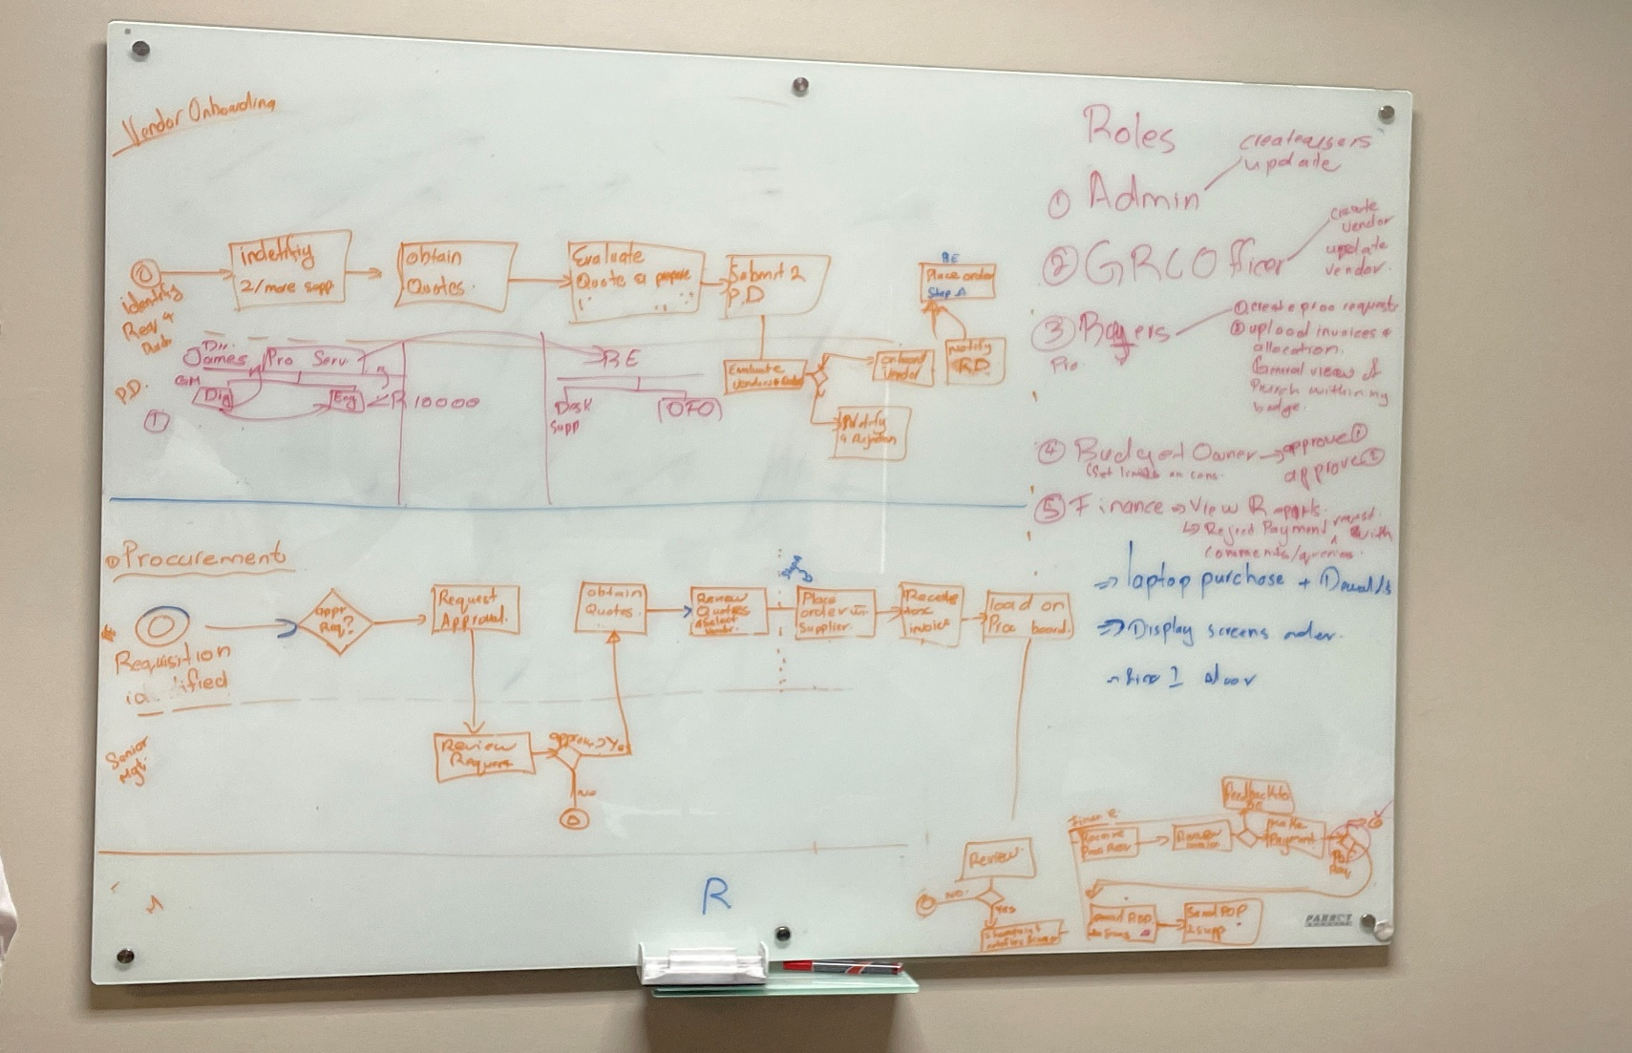

# 4.8 Conclusion

In conclusion, the problems, opportunities, directives and business goals and objectives have been analyzed and the requirements have been identified as well as explored. Thus, the preliminary investigation is completed and has provided us valuable insight within the not only current system but the future system. This will help us in creating and completing the future procurement system for our client MOYO.

Problem analysis

# 5.1 Introduction

In this section, the problem will clearly be defined by providing an overview of the current system, an analysis of the system’s capabilities, the required system’s capabilities, as well as the gaps between capabilities and recommendations by the Altean team to resolve these gaps.

# 5.2 Overview of current system

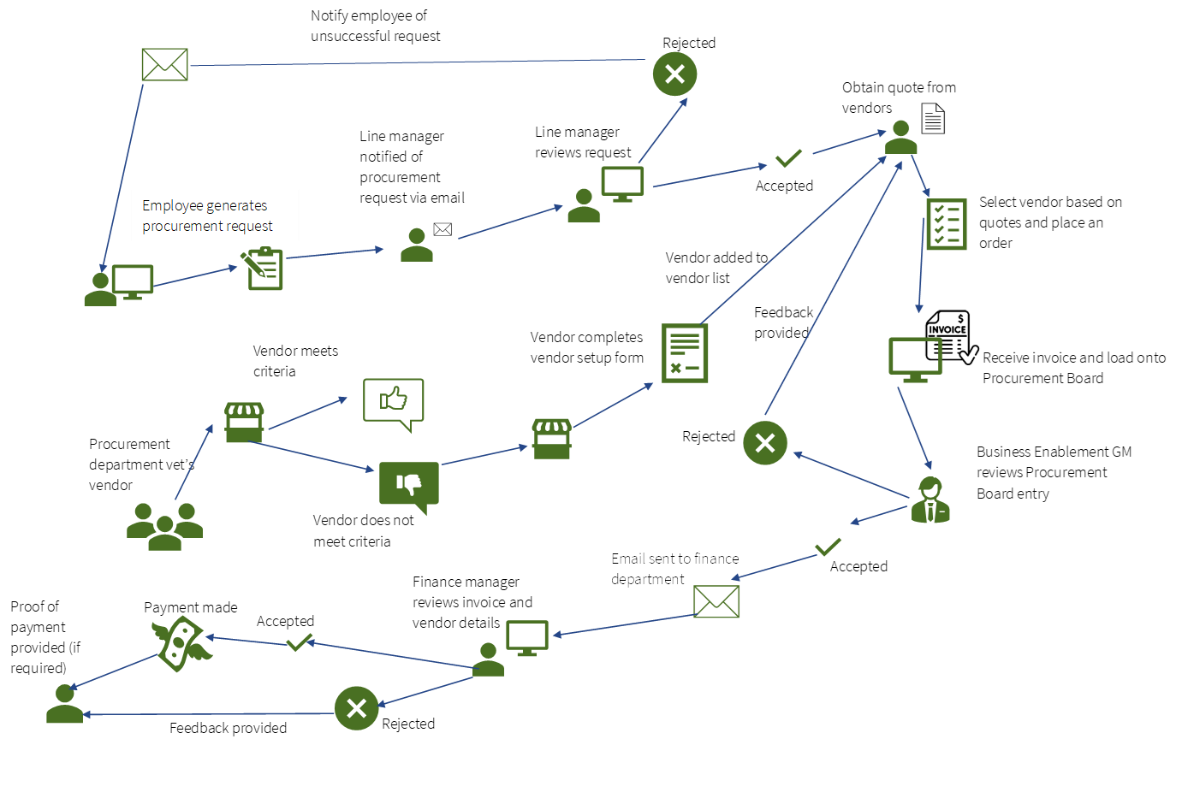

# 5.2 System’s capabilities

|  |  |  |  |  |
| --- | --- | --- | --- | --- |
|  | Current System Capabilities | Required System Capabilities | Capability Gaps | Recommendations |
| Vendor Onboarding | Current system requires vendors to be manually vetted by the procurement department.  Vetting is performed by making use of the Vendor Due Diligence Checklist.  Vendors that meet criteria for vendor selection must complete a vendor setup form.  When required, evaluation is conducted by selecting the best value match vendor from multiple bidding vendors. | The system should be able to assist the procurement department in vetting vendors by centralizing and streamlining the vetting procedures and processes.  The procurement department should be able to directly vet venders through the system. | The management of vendors during the onboarding process can be disorderly, as the process mainly takes place via email, and this form of communication can be easy to lose track of for repetitive tasks like vendor onboarding. | The system should make use of the Vendor Due Diligence Checklist to ensure that the process is in line with the procedures laid out by the company Procurement Policy.  The procurement department should be able to export the completed Due Diligence Checklist from the system.  The procurement department should be able to send out vendor setup forms through the system. |
| Purchasing process | Employee generates procurement request through SharePoint or via email.  Procurement request is reviewed by a line manager and either accepted or rejected.  Quotes are obtained from vendors, and then the most suitable vendor is selected.  An order is placed with this vendor and a tax invoice is received and placed on the procurement board.  Invoice reviewed by the Finance department and paid for, after which proof of purchase is received. | All prospective buyers (employees) should be able to generate procurement requests through the system.  Procurement requests should be reviewed and either approved or rejected by the relevant line manager.  Multiple quotes from different vendors must mandatorily be obtained before they are reviewed, and a vendor is selected. | Some employees use email while some use SharePoint. There is no singular platform which every employee uses, which creates confusion among employees.  There is no way to easily track procurement requests.  An adequate number of quotes is not always received before items are purchased.  Due diligence is being bypassed. | Review of procurement requests and invoices should be able to be delegated to other managers in cases where the direct line manager is not able to review them themselves.  Procurement requests will have to conform to the company Procurement Policy. |
| Consumable Inventory Management | N/A | Consumable inventory should be managed using the required system.  It should be possible to have a read on the inventory levels of all consumables through the system.  A notification should be sent when an inventory item is low on stock, indicating that a restock is required. | Current system does not have an inventory management system specifically for consumables.  Restock may at times only take place when a consumable has already run out of stock. | Forecasting should be used to forecast when consumables will be low in stock, and a relevant notification should be generated accordingly.  The system should display the numbers of different consumables in stock, and it should be possible to search for the stock levels of specific consumables. |
| Business Unit Budget Allocation | In the current system, the budget for each business unit is kept track of manually by budget owners. | It should be possible to maintain a read on each business unit’s budget by making use of reports.  It should not be possible for a procurement request with invalid information to be completed. | Difficult to manage budgets due to difficulty locating different procurement requests.  Weekly processing is disrupted due to incorrect information being present, thus time is wasted going back and forth getting the correct information.  Employees can sneak items into the inappropriate procurement request, which will negatively impact the wrong unit’s budget. | The system should have search functionality which allows items forming a budget to easily be located. |
| Invoice Allocation Process | Requestor uploads invoice and selects budget line after a purchase has been made.  The invoice is submitted to the budget owner for approval.  The budget owner reviews the request, and if approved the payment or invoice is allocated accordingly by the Finance department. | The system should support the review of invoices to allow the Finance department to allocate payments or invoices as needed in a more efficient manner. | The current system requires invoices to be manually reviewed via email, which can lead to some invoices being lost due to high email volume, or the approval process being slowed down which represent critical inefficiencies in the current invoice allocation process. | Strict access control should be present on the ability to review and approve invoices to ensure security and integrity. |

# 5.3 overview of Proposed System



# 5.4 conclusion

In conclusion, the analysis of the current system as well as 6. Functional requirments

## 6.1 Introduction

## 6.2 Functional requirement list

## 6.3 Functional requirements description

## 6.4 Non-functional requirements

## 6.5 Conclusion

Appendix A

# 5.1.1 Procurement process:

**Procurement page:**

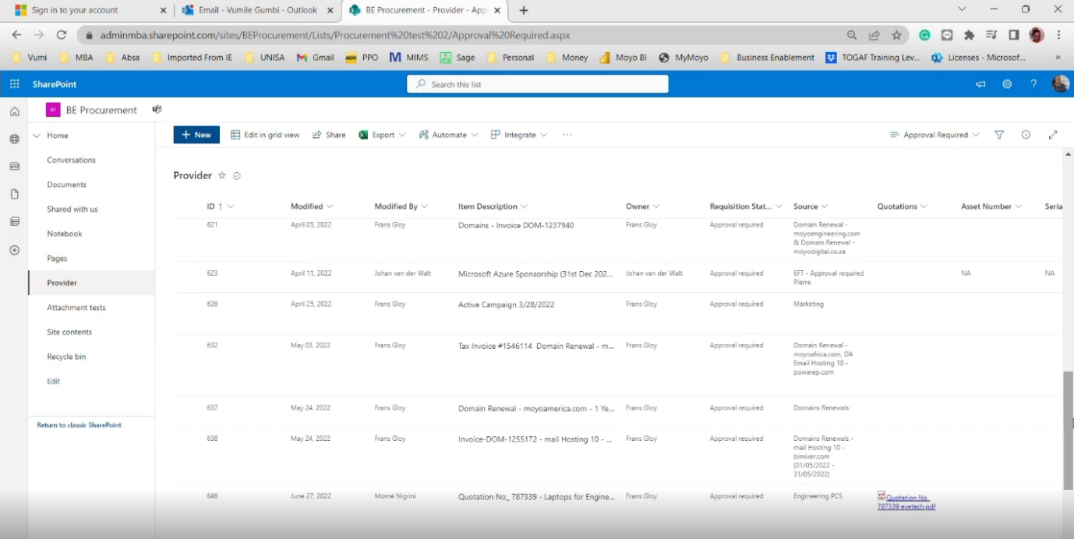

Figure Procurement request page

Step 1:

Navigate to your company division SharePoint page, the following list shows relevant requisition lists.

Step 2:

1. Create a new request by clicking on the “New” button, and populating the relevant information on the fly-out pane to the left where possible: (Please note, fields marked with an asterisk are compulsoryGraphical user interface, application, Word

   Description automatically generated

Figure Create a new request

1. Owner *:

This is a compulsory field used to identify who is raising the request, Put in your own name here:

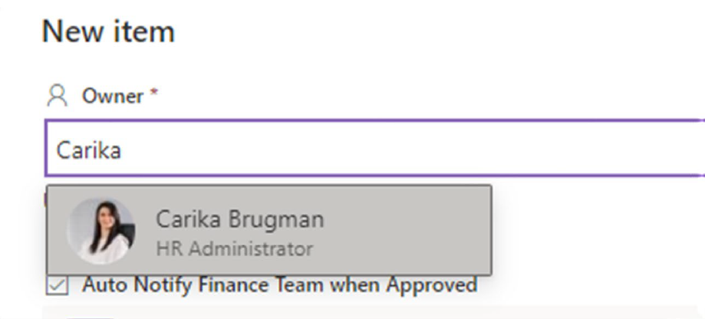

Figure Choosing an owner

1. Switch off “Auto Notify Finance Team When Approved”:

To prevent sending irrelevant notifications to Finance, set this setting to “No” for now. This setting may be enabled by management on approval.

Figure Auto Notification

1. Requisition status

Set “Requisition Status” * to “Approval Required”: This setting will be monitored by management and set to “approved” or “declined”, depending on the decision outcome. Note that this is a compulsory field.

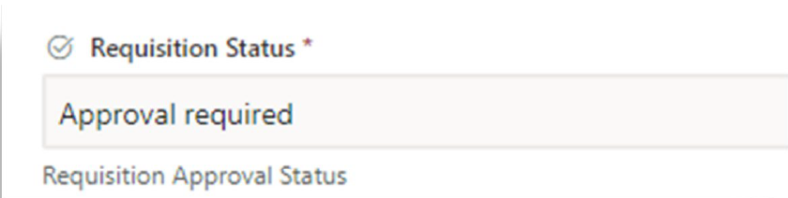

Figure Requisition Status

1. Source *:

This is another compulsory field, used to indicate where the approval request originates from, you can reference a person, Service Desk ticket number, e-mail subject line for example.

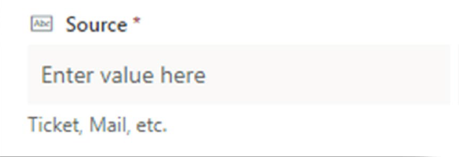

Figure Source

1. Quotations:

Although this field is not compulsory, the cost of the service or item that needs to be obtained, will need to be approved as indicated by point 1.3. as soon as you receive a quote upload it to SharePoint and copy the link to the file here. This will ensure the estimated cost of a service or item is accurate (see Point 1.)

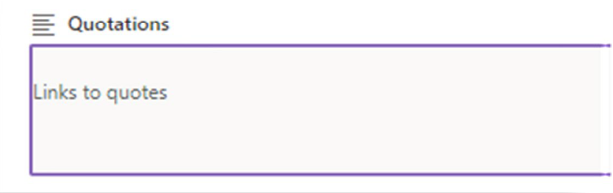

Figure Quotations

1. Asset / Serial number:

this optional field is used to indicate the company asset number and serial number, respectively. This only pertains to items in general, these fields will not be known until delivery of the item. you can skip this section for now.

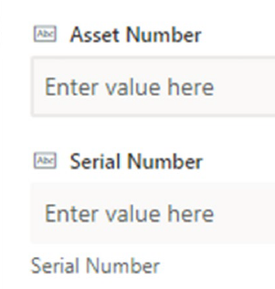

Figure Asset number and serial number

1. Provider *:

This compulsory field is used to identify the service provider or retailer used when obtaining original quotations. You can select the relevant provider from the dropdown list provided. a pre-configured list of providers is already present.

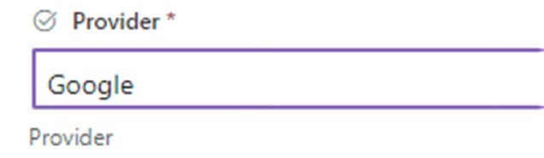

Figure Provider

1. Deposit Due Date:

This field is used to indicate to Finance when the deposit for a requisition item is due. this is an optional field and can be left empty if no deposit is to be paid. You can also click on the Calendar icon to the right of the input pane to choose a date from the pop-out calendar.

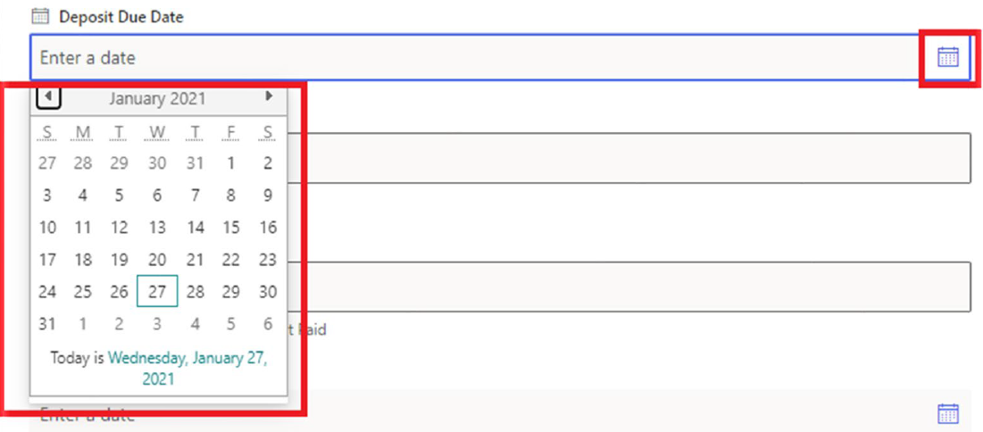

Figure Deposit Due Date

1. Deposit Amount:

Specify the amount due for the deposit to paid on the due date listed in point 1.8.

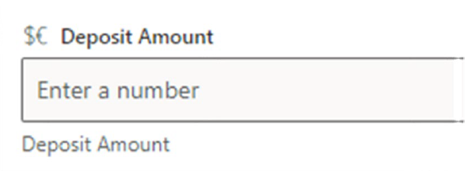

Figure Deposit Amount

1. Amount Outstanding:

Specify the total amount due when subtracting the value listed in point 1.9.

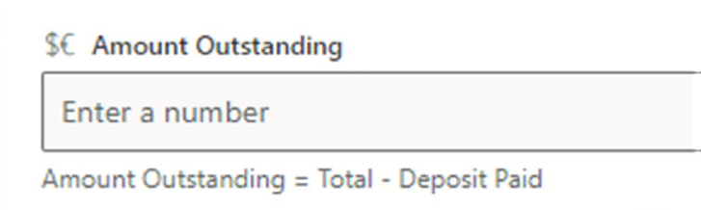

Figure Amount Outstanding

1. Full Payment Due Date *:

Compulsory field. Specify the date when the full amount is to be paid. Click on the Calendar icon to the right of the input pane to choose a date from the pop-out calendar.

Figure Full Payment Date

1. Total Amount:

Specify the amount due for payment in full on the date listed above. if no quotation or invoice is available in point 1.x an estimated cost will suffice for budget projections if the item or service is to be actioned in the future.

Figure Total Amount

1. Paid on:

When a payment has already been settled by credit card, EFT, or debit order, specify the date for the transaction here.

Figure Paid On

1. Budget Allocation *:

A predefined list of Budget Allocation areas are available by clicking on “Select Options”. Please note that this field is especially important for Finance to know which budget a procurement task belongs to, so special care needs to be taken to ensure this field is correct.

**This field is compulsory.**

Figure Budget Allocation

1. Procurement Status *: Graphical user interface, text, application, chat or text message

   Description automatically generated

Figure Procurement Status

This field is used to indicate the progress of the procurement task. Available options are as follows:

* Requisition Approval required.
  + Use this status to indicate the need.
* Get Quote
  + Use this status to indicate that a quote was requested from the supplier, but not yet received to attach to the procurement task.
* Quote Approval Required
  + Normal procurement procedure states that 3 different quotes should be obtained first, before any purchases can be made. This status field is used to indicate that the attached quotations need to be signed off on.
* Ready to order/purchase
  + Management may set this status to indicate that procurement should proceed, once a quotation has been approved.
* Quote Declined
  + Management may set this status to indicate that the quotation was not sufficient, or that budget does not allow for the procurement item at this time.
* Awaiting Delivery
  + use this status when an order was placed, but items / services have not been delivered yet.
* Item Received and checked
  + used to indicate on delivery of an item or a service, that the condition was satisfactory
* Asset to be registered
  + If an asset needs to be asset tagged, this status may be used to indicate that the asset number still needs to be listed with finance, or that Finance may need to generate one.
* - Asset Registered
  + indicates asset tagging has been completed
* - Done
  + indicates that the procurement task has been completed

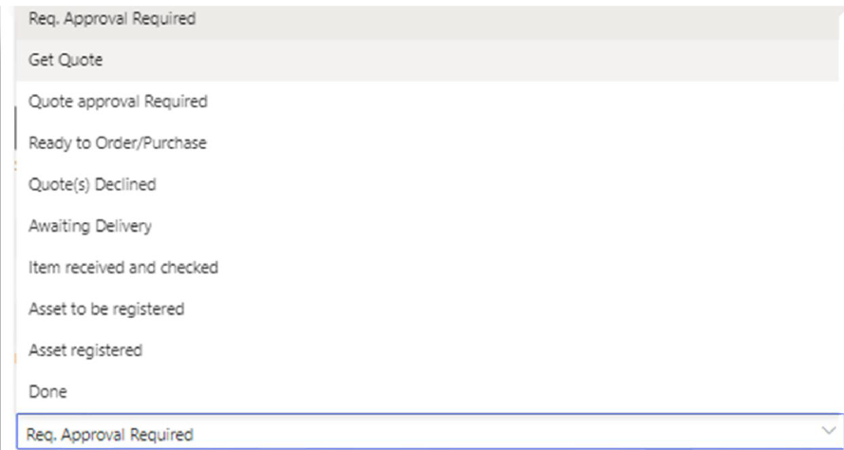

Figure Procurement Status Options

1. Payment Method *:

Can only be one of 3 different methods:

* + Credit Card – used when the purchase was made using a card
  + EFT – Used when payment is to be manually made by Finance
  + Cash Payment – Used when a cash payment was made, attach the till slip together with the invoice in the next field.
  + Please note: this is another mandatory field.

Figure Payment Method

1. Invoices:

this field is used to attach the links to invoices, or to upload digital invoices directly on the list.

Figure Invoices

1. Payment Status *:

Use the dropdown list to indicate the status of the payment:

Figure Payment status

1. For finance

* No Action
  + No Action Required.
* Deposit Payment Required
  + If the supplier requires a deposit this option needs to be selected.
* Paid Deposit Only
  + Once Finance has paid the Supplier the deposit this option should be selected.
* Allocation required
  + Finance to Allocate / Load the item for payment.
* Allocation Made
  + If allocation was done by finance.
* Total Payment required
  + If the total payment is needed this option should be selected.
* Paid Total
  + If the total amount was paid to the supplier.
* Partially paid -see comments
  + If only deposit was paid and still requires another payment. This needs to be added in the comments section.
* Paid – Allocated to correct GL
  + If finance made the payment and allocated the payment to the correct GL “General ledger”.
* Allocated to correct GL account
  + If finance allocated the payment to the correct GL account.
* Allocation required.
  + Finance to allocate the procurement item for payment.

Figure Finance Allocations

1. Comments:

Comments may be inserted here to indicate specific payment instructions, requests or notifications from Management, or reasons why procurement tasks are declined for example.

Figure Comments

1. CC Providers?

Yes/No field to indicate to finance that a copy of the proof of payment is required.

Figure CC Provider

1. Sign-off Status:

This field is used by management to indicate that a task may be closed.

Figure Sign-off

1. Provider’s e-Mail:

the suppliers e-mail address (not compulsory)

Figure Providers E-mail

1. Attachments:

Any additional attachments may be added here. (Due to a recent update on SharePoint Online, this field may be the only possible way to upload invoices for now, when using the modern layout).

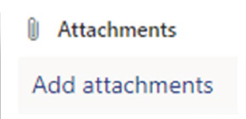

Figure Attachments

* Documentation Required for Approver

1. Requisition Status:

The requisition status needs to be changed to approved. Finance will receive a notification once this item was approved to load the procurement item for payment. If the requisition status was set to decline by the approver, no action will be required.

Figure Requisition Status

# Procurement Policy

1. **The objective of the Procurement policy**

The role of the Procurement policy is to define standard methods and procedures for the Company to purchase products and services from different vendors.

This policy covers all expenses for the company including items like taxes, payroll payments, etc. Non-vendor payments are defined as exceptions in the policy and proper procedures to manage these payments are included in section 3.

The Services Partner procedure should be applied when making use of service partners or enrolling new service partners.

Compliance with this policy is mandatory for all employees. Non-compliance with this policy could lead to action including termination of employment.

The Procurement department, under leadership of the Commercial Finance Executive is responsible for maintaining and implementing the processes defined in this policy.

1. **Role of the Procurement Department**

The role of the Procurement department is to assist the organization get the best value for the product and services purchased, reduce cost, reduce supply risk, and enabling stakeholders to reach their business goals.

The Procurement department is responsible for running the vendor selection process by working with different stakeholders. The Procurement department would be the main point of contact for the suppliers during the vendor evaluation and selection process.

Procurement will coordinate the activities, schedule, and scoring of the vendor responses by working with both internal and external stakeholders.

1. **Vendor setup and onboarding process**

All new vendors will be vetted by the Procurement department to ensure that they meet criteria for vendor selection before completing the vendor setup form. Vetting will be done using the Vendor Due Diligence Checklist (Figure 35) and Protection of Personal Information Checklist (Figure 36).

If required, an evaluation should be conducted by inviting multiple vendors to bid and then selecting the best value match vendor for the company.

Procurement may only be done from approved vendors. Should urgent purchases be made with a non-accredited vendor, then approval should be obtained from the Managing Director in advance. This approval should accompany the order request sent to the Procurement department. This applies in exceptional circumstances and one-off purchases only. Should the same vendor be used again, then the vendor setup form should be completed, and the vendor should be added to the approved vendor list before purchases are made.

Please note that this process is applicable to standard vendors. There are exceptions that would not be vetted by the Procurement department. Those exceptions include:

1. Taxes

2. Interest and bank payments

3. Government payments.

4. Service partner selection (to follow the Service Partner Procedure)

5. Reimbursements

Once vetted, the approved Vendor Setup Request form must be submitted to the Accounts Payable Department with supporting documents.

The Vendor Setup Form should also be submitted when an existing vendor’s details have changed.

Refer Figure 31 for the Vendor Setup Request form.

All Vendor Setup Requests must be approved by the relevant Executive and be accompanied by the Vendor Due Diligence Checklist and PPI Checklist.

**Sole suppliers and preferred vendors**

Where there is a need to make use of sole suppliers or preferred vendors, this should be indicated on the vendor setup request form.

All requests for sole suppliers and preferred vendors must be approved by the Managing Director.

Sole suppliers and preferred vendors should be reviewed at least once a year when supplier performance should be evaluated, and comparative quotes should be obtained. The renewal of a sole supplier or preferred vendor must be approved by the Managing Director. An e-mail containing the evaluation of supplier performance, comparative quotes as well as the motivation and approval for renewal should be submitted to the Procurement department annually. Failing to renew may result in orders not being placed with the sole supplier or preferred vendor and procurement being delayed as the mandatory two quotes will be required.

**Ad-hoc purchases and sundry payments**

Ad hoc purchases (e.g. credit card purchases or one-off purchases) and sundry payments relate to purchases or payments that cannot (due to specific circumstances) be processed using the formal procurement procedures and are therefore not linked to an official order. Payment shall be processed on receipt of an invoice (in the case of credit card purchases, the credit card slip should be submitted along with the invoice) from the relevant user department and approved by the relevant budget owner.

Notifications of ad-hoc purchases should be e-mailed to procurement.

Requests for sundry payments should be e-mailed, with the necessary supporting documentation and appropriate authorization to payments. The supporting documentation will include:

* Budget line allocation
* Bank stamped letter confirming banking details of the supplier (not required for credit card purchases)
* Confirmation of supplier VAT number (not required for credit card purchases)

For purposes of authorization of sundry payments, a Sundry Payment Approval Stamp will be implemented which should accompany the request for sundry payments (Refer Figure 34). Payments will be done weekly on Thursday.

1. **Contract signing Authority**

The contract signing authority is regulated by the Moyo Business Advisory Group of Companies Delegation of Authority (DoA) as approved by the Board.

The DoA prescribes that all supplier agreements, excluding financing arrangements, must be approved jointly by the Managing Director and the Commercial Finance Executive.

1. **Procurement authority levels**

Procurement authority levels specify what amount is authorized at what level of the organization before the payment can be made to the supplier.

This is applicable to both purchase orders and other expenses / Invoice payments (without a purchase order).

All purchases must be approved at the appropriate level based on the total amount of the requisition. The following matrix provides authorization limits based on job titles as per the DoA.

1. **Delegation of authority**

This Delegation of authority section provides guidelines on how an approver can delegate their approval authority levels to someone else. A delegation of authority in this case is temporary – for example, when an approver goes on vacation.

The standard Delegation of Authority form (Figure 32) should be completed when an approver temporarily delegates their approval authority. The delegation should be approved by the Managing Director.

A copy of the form should be sent to the Procurement and Accounts Payable departments as well as the HR department for record keeping.

1. **Procurement process and accepted norms**

**Process flow**

The following diagram shows the high-level procure to pay process that is followed once a demand for products or services has been identified:

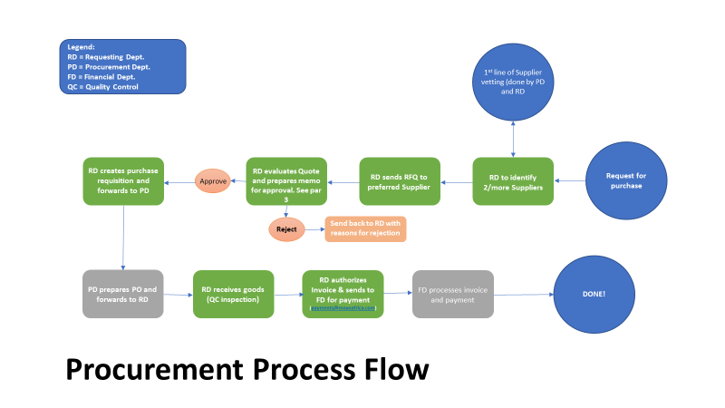

Figure Procurement Process Flow

**Requisition process**

To purchase a product or service, the requester will create an entry for procurement in SharePoint.

Once the request to procure is approved by the budget owner, the requester needs to obtain at least 2 quotes from different vendors and upload with the request, unless a sole supplier or preferred vendor is selected (subject to sole supplier or preferred vendor approval process).

**Approval process**

Each requisition must be approved as per the Procurement authority levels defined in Section 5.

**Purchase order process**

Once the purchase order is confirmed, the Procurement Officer will send the purchase order to the vendor.

A Procurement Manual is available to explain the process for loading procurement requests in SharePoint.

1. **Invoicing process and guidelines**

This section outlines the process that vendors need to follow to submit invoices for payment as well as internal users needing to submit a request for payments or other invoices where a purchase order is not applicable.

Once goods or services have been received in good order, an invoice is provided by the vendor. The invoice should be approved by the relevant Budget Owner before submitting it, along with proof of receipt (in some cases this is included on the invoice), to the Accounts Payable department. The e-mail should include the supporting documents, the approval and the budget line item to be debited.

1. **Competitive bidding**

Budget Owners should secure their own competitive bids from multiple suppliers unless use is made of a sole supplier or preferred vendor as approved during the vendor setup process.

The budget owner has the discretion to select the appropriate vendor but should take into consideration the best value based on the quality of the product and the price quoted.

1. **Ethical Procurement and conflict of Interest**

A conflict of interest a situation in which the concerns or aims of two different parties are incompatible. In other words, if the person making the Procurement decision is somehow going to benefit from the purchase transaction, then there is a conflict of interest.

In case of a real or perceived conflict of interest, the Budget Owner must adhere to the requirements contained in the Managing Conflicts of Interest Policy.

Moyo conducts all its business in an honest and ethical manner. Bribery is a criminal offence. Moyo takes a zero-tolerance approach to bribery and corruption in all its forms. All employees must consider the requirements of the Anti-Bribery and Anti-Corruption Policy when entering into supply agreements and procurement transactions.

Moyo will avoid the intent and appearance of unethical or compromising practice in relationships, actions and communications. Moyo will not permit impropriety at any time and employees will not use corporate assets or business relationships for personal use or gain. You are referred to Moyo’s Ethics Policy in this regard.

1. **Supplier diversity**

As a good corporate citizen, Moyo is committed to promoting equitable procurement practices. Budget Owners are required to apply the Preferential Procurement Guidelines in this regard.

1. **Compliance**

***Compliance Measurement***

The Procurement Department will monitor compliance to this policy on an ongoing basis.

***Exceptions***

Any exception to the policy must be approved by the Managing Director in advance.

***Non-Compliance***

Any employee found to have violated this policy may be subject to disciplinary action, up to and including termination of employment.

1. **Related Standards, Policies and Procedures**

Anti-Bribery and Anti-Corruption Policy.  
Ethics Policy.  
Managing Conflicts of Interest Policy.  
Vendor Selection and Due Diligence Process  
Preferential Procurement Guideline.  
Service Partners Procedure.  
Information and Document Retention Policy.

Figure Delegation of authority

Figure Vendor Setup/Update

Figure Sundry Payment approval stamp

Figure Vendor Due Diligence Checklist Part 1

Figure Vendor Due Diligence Checklist Part 2

# Procurement email notifications example

Figure Procurement Email notification

# Operations Budget Allocation

Figure Operations Budget Allocation

# BEE Procurement Analysis



Figure BEE Procurement Analysis

Appendix B

# Alternative 1:

Oracle NetSuite

URL: <https://www.netsuite.com/portal/products/erp.shtml>

Oracle NetSuite is an integrated cloud-based software suite including ERP, Accounting, GBM, CRM, HRM, PSA, Commerce, Analytics & Reporting, Infrastructure, and Platform software.

**Some functionalities include:**

* Financial management
  + Planning and Budgeting
  + Financial Reporting
  + Financial Consolidation
* Inventory Management
  + Replenishment/procurement
  + Traceability
* Order Management
* Reporting & Dashboards

**Advantages:**

* Functionality covers all sections of the business processes.
* No maintenance of the software needs to be done, as the user rents a license for a set period of time.
* The procurement of items is made very efficient and done effectively by producing a single data source from the procurement information and by automating the order management process.
* Allows for resource management and forecasting with regards to inventory stock.

**Disadvantages:**

* The price of the software increases as the user adds more functionality/modules.
* The user can not freely customize the software and has to pay to have it customized.
* The user has to pay a large once-off implementation and integration fee, depending on how big the system is.
* Basic support is limited, and the user has to pay for additional support.

**Verdict**

Based on the information that was gathered, Oracle NetSuite is a perfect software that can be used and implemented into the company to address their issues. However, the financial costs needed to acquire and use the system might pose too much to the company as well as only being able to customize the software by paying for it. Our team aims to provide a system that will have the same type of usability but at a far greater and less cost.

# Alternative 2:

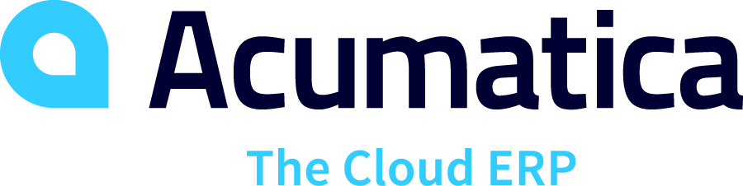Acumatica

URL: <https://www.acumatica.com/>

Acumatica is a cloud-based ERP system with the ability to be implemented on mobile devices. Acumatica, like Oracle NetSuite, contains a number of different functionalities of which all can be used to address the business’s needs.

**Some functionalities include:**

* Inventory replenishment/procurement
* Physical inventory management
* Vendor management
* Stock turnover
* Financial and inventory reporting
* Order management

**Advantages:**

* Provides an all-in-one system containing all the needed functionality.
* Optimizes stock monitoring and providing a fast stock ordering process.
* The dashboards that the users can make use of can be personally customized by them to fit their needs.

**Disadvantages:**

* The price of the system increases as the user adds more functionality and/or modules to the system.
* Implementation of the system can pose to be difficult due to the number of customization options and the various features it has.
* Integration of the system may cause conflict when trying to integrate with some legacy systems.

**Verdict**

Based on the information gathered, Acumatica, like Oracle NetSuite, provides the user with a number of functionalities to be implemented and which can be used to address the business problems that our client has. However, like with NetSuite the pricing of the system may discourage the user from acquiring this service as well as the problems faced with the implementation and integration of the system. Our team thus strives to provide a system that will greatly reduce the trouble faced with the integration and implementation of the system.

Team Sign off

***PROCION SYSTEM: Project Request***

We, team 11, understand and acknowledge, have reviewed the information contained in the document (Project Proposal), and we confirm and understand the contents and that the information provided is true.

**BY SIGNING BELOW WE AGREE TO THE FOLLOWING:**

1. We understand the goals and the objectives of the project, as well as the specific tasks and responsibilities assigned to us.
2. We agree that our assigned tasks have been completed and meet the required quality standards
3. We agree that any issues, risks and concerns have been appropriately addressed and resolved.
4. Acknowledge that any changes or revisions to the document have been made and agreed upon by the project team
5. That each team member has contributed equally to the iteration

|  |  |  |  |  |
| --- | --- | --- | --- | --- |
| **Signed by:** | | | | |
| **Name:** Jason vd Merwe | **Name:** Leon Combrinck | **Name:** Bupe Chindongo | **Name:** Werner Schutte | **Name:** Emil Wonigkeit |
| **Date:**2023-03-08 | **Date:** 2023-03-08 | **Date:** 2023-03-08 | **Date:** 2023-03-08 | **Date:** 2023-03-08 |
| **Signature:** | **Signature:** | **Signature:** | **Signature:** | **Signature:** |

Client sign off

***PROCION SYSTEM: Project Request***

***Business Name: Moyo Business advisory***

I,_______________________________,hereby confirm that I have read the document and agree that the information contained therein is complete, accurate and meets the requirements of the project.

**BY SIGNING I CONFIRM THAT:**

1. **I have reviewed the deliverable as outlined in this project**
2. **I accept the deliverable as complete and satisfactory.**

|  |
| --- |
| **Signed by:** |
| **Name:** |
| **Date:** |
| **Signature:** |